**Circuit and System-I**

**LAB # 07**



**Spring 2022**

Submitted by: Suleman Shah

Registration No.: **21PWCSE1983**

Class Section: **C**

“On my honor, as student of University of Engineering and Technology, I have neither given nor received unauthorized assistance on this academic work.”

Student Signature: ______________

Submitted to:

**Engr. Faiz Ullah**

2 June, 2022

Department of Computer Systems Engineering

**ASSESSMENT RUBRICS LAB # 7**

**Node Voltage Analysis using PSPICE**

|  |  |  |  |  |
| --- | --- | --- | --- | --- |
| **LAB REPORT ASSESSMENT** | | | | |
| **Criteria** | **Excellent** | **Average** | **Nill** | **Marks Obtained** |
| 1. **Objectives of Lab** | All objectives of lab are properly covered  [Marks 0.5] | Objectives of lab are partially covered  [Marks 0.25] | Objectives of lab are not shown  [Marks 0] |  |
| 1. **Node Voltage Analysis**   **(Theory, Circuit Diagram )** | Brief introduction about Node Voltage Analysis (what is Node voltage analysis, What are nodes, How to apply KCL equations at each node) is shown along with properly labeled circuit diagram  [Marks 1] | Some of the points about Node Voltage Analysis are missing and circuit diagram is not properly labeled  [Marks 0.5] | Introduction about Node Voltage Analysis and circuit diagram is not shown  [Marks 0] |  |
| 1. **PSPICE**   **Simulator** | Brief introduction of PSPICE simulator  [Marks 1] | Brief introduction of PSPICE simulator  Is not shown  [Marks 0] | |  |
| 1. **Procedure** | All experimental steps are shown in detail along with how to verify Node Voltage Analysis.  [Marks 1.5] | Some of the experimental steps are missing  [Marks 1] | Experimental steps are missing  [Marks 0] |  |
| 1. **Observations & Calculations** | Mathematical calculations are shown and comparison with PSPICE results.  [Marks 5] | Mathematical calculations are shown but no comparison with PSPICE results  [Marks 2.5] | No mathematical calculations are shown  [Marks 0] |  |
| 1. **Conclusion** | Conclusion about experiment is shown  [Marks 1] | Conclusion about experiment is partially shown  [Marks 0.5] | Conclusion about experiment is not shown  [Marks 0] |  |
| Total Marks Obtained:__________  Instructor Signature: ______________________ | | | | |

**Title:**

**Node Voltage Analysis using PSPICE**

**Objectives** :

* To know about Node voltage method.
* How to calculate node voltages in a circuit.
* Verifying Node Voltage Method.

**Node Voltage ANALYSIS :**

The mathematical method for calculating the distribution of voltage between the nodes in a circuit.

**node :**

A point at which two or more elements are joints together is called node.

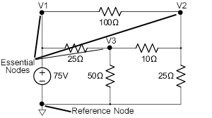

Figure 1

**Writing Node Voltage Method for Figure 1:**

**At Node V2:**

$\frac{V_{2}-75}{100}+\frac{V_{2}}{25}+\frac{V_{2}-V_{3}}{10}=0$

**At Node V3:**

$\frac{V_{3}-75}{25}+\frac{V_{3}}{50}+\frac{V_{3}-V_{2}}{10}=0$

**Kirchhoff’s current law (KCL):**

In 1847, Gustav Robert Kirchhoff, a professor at the University of Berlin, formulated two important laws that provide the foundation for analysis of electric circuits. These laws are referred to as Kirchhoff’s current law (KCL) and Kirchhoff’s voltage law (KVL) in his honor. Kirchhoff’s laws are a consequence of conservation of charge and conservation of energy. Kirchhoff’s current law states that the algebraic sum of the currents entering any node is identically zero for all instants of time.

**STATEMENT:**

The algebraic sum of the currents into a node at any instant is zero.

**MATHEMATICAL FORM :**

∑I = 0

**Circuit Diagram :**

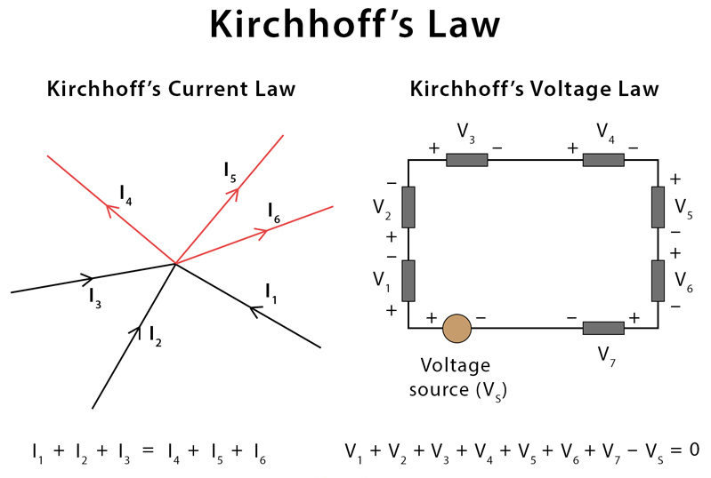

**PSPICE:**

**PSpice** is a SPICE analog circuit and digital logic simulation software that runs on personal computers, hence the first letter "P" in its name. It was developed by MicroSim and is used in electronic design automation. MicroSim was bought by OrCAD which was subsequently purchased by Cadence Design Systems. The name is an acronym for Personal Simulation Program with Integrated Circuit Emphasis. Today it has evolved into an analog mixed signal simulator.

OR

“PSPICE is a circuit analysis tool that allows the user to simulate a circuit and extract key voltages and currents.”

**Node Voltage Method:**

The Node Voltage Method breaks down circuit analysis into this sequence of steps,

* Assign a reference node (ground).
* Assign node voltage names to the remaining nodes.
* Solve the easy nodes first, the ones with a voltage source connected to the reference node.
* Write Kirchhoff's Current Law for each node. Do Ohm's Law in your head.
* Solve the resulting system of equations for all node voltages.
* Solve for any currents you want to know using Ohm's Law.

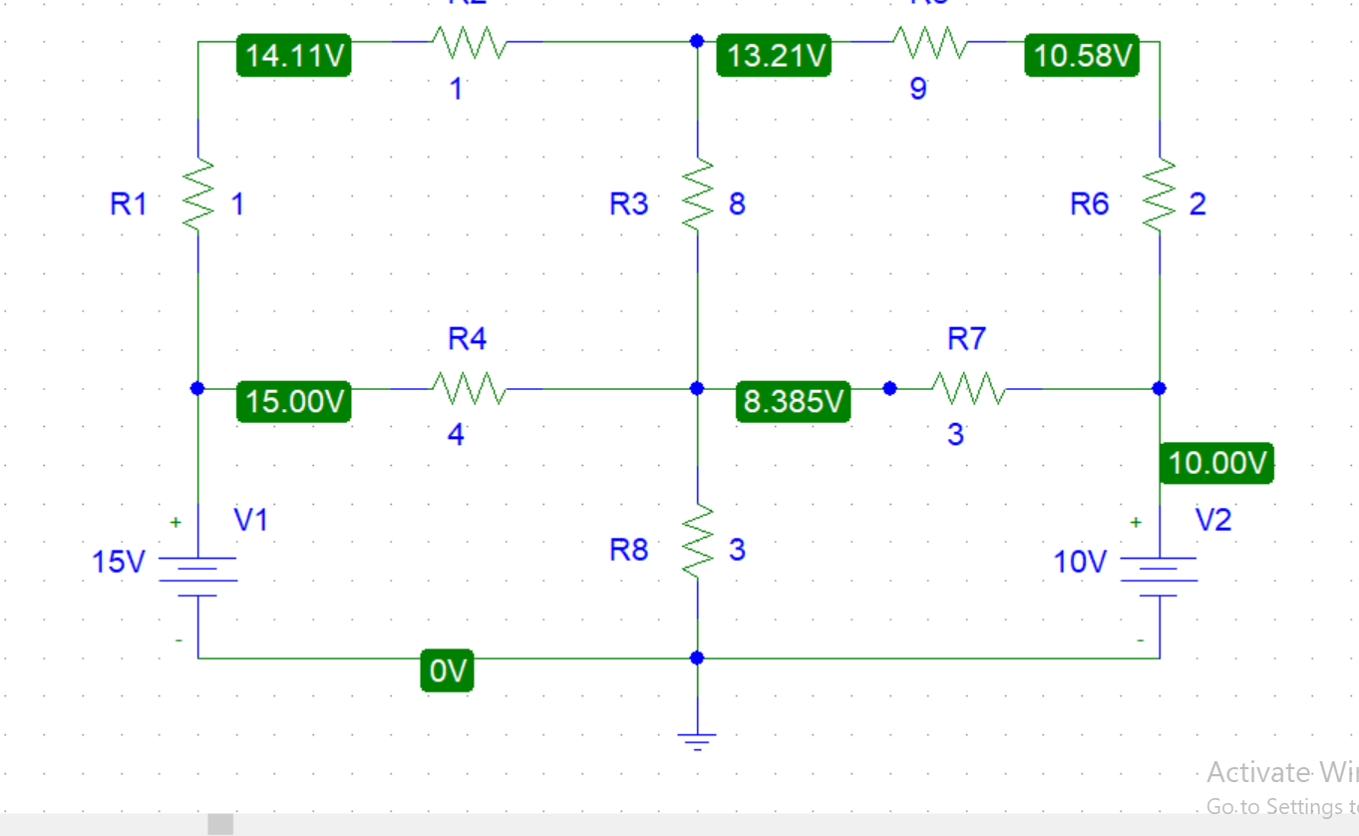

Figure 2

**APPLYING NODE VOLTAGE METHOD ON FIGURE 1:**

**SUPPOSITION:**

Let’s suppose in figure 2.

*i1*is flowing through R1 & R2. *i3*is flowing through R3. *i4*is flowing through R4.

*i6*is flowing through R6 & R5. *i7*is flowing through R7. *i8*is flowing through R8.

Now applying KCL at node V2 and V3.

**At Node V2:**

$i_{1}+i_{6}{-i}_{3}=0$

**At Node V3:**

$i_{4}+i_{7}+i_{3}{-i}_{8}=0$

Now after applying Ohm’s Law in above equations, I calculated V2

And V3 as:

**V2 = 13.2V** & **V3 = 8.33V**

**VERIFICATION IN PSPICE:**



**PROCEDURE:**

1. Open schematic program of PSpice
2. Click on the “Get New Part” button on the toolbar
3. Type ‘r’ in the search bar and place the eight resistors on the white sheet
4. Type ‘vdc’ in the search bar and place two of them on the white sheet
5. Type ‘gnd-earth’ and place it on the white sheet
6. Now arrange these components on the white sheet according to the circuit diagram as following
7. After arranging click on simulate button and the following results are generated

**Observation:**



**CONCLUSION:**

In accordance with the Node Voltage Analysis, we made use of Kirchhoff’s Current law to arrive at a system of equations which aims to calculate the node voltages. The calculated voltages were then verified in PSPICE Simulator. PSCPICE Confirmed the calculations of Node Voltage Method. Errors were also arised in the calculated values because of low precision. The errors were negligibly small to ignore.